**Assignment 6 - Dominick Girard - CSCI 250**

C++ ADTs  
  
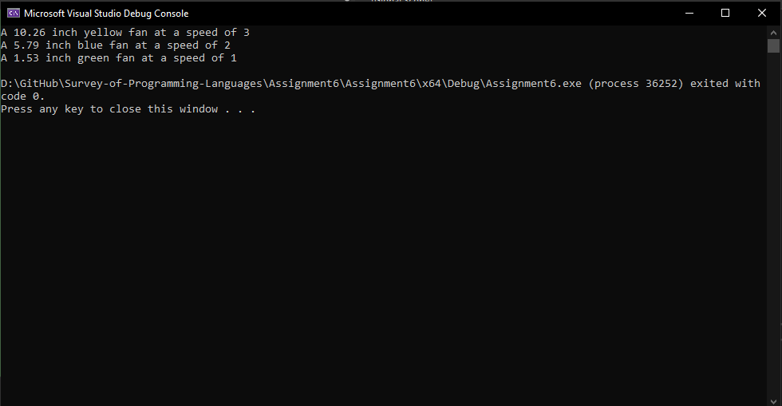

C# ADTs

• **Simplicity and Readability**: Properties provide a cleaner and more concise way to define accessors and mutators. They reduce boilerplate code and make the class definition more readable.

• **Encapsulation**: Properties encapsulate a field while exposing a public way of getting and setting its value. This preserves the principles of encapsulation.

Ruby ADTs

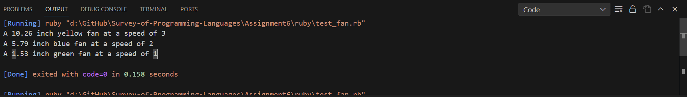

**Ruby's attr_* Methods**: These are extremely concise and readable, reducing boilerplate significantly. They are ideal for simple cases where complex logic in getters/setters is not needed.

**Specific Get/Set Methods**: While these methods offer the most control and are language-agnostic, they require more boilerplate code and can make the class less readable, especially for simple data handling.